CUSTOMER

* First, you need to go to the homepage of CleckShopHub, then click on the Login button from the top right of the navigation bar

[Register Testing]

* If the trader clicks on Sign Up button without entering anything in the input fields then all the empty fields are highlighted in red

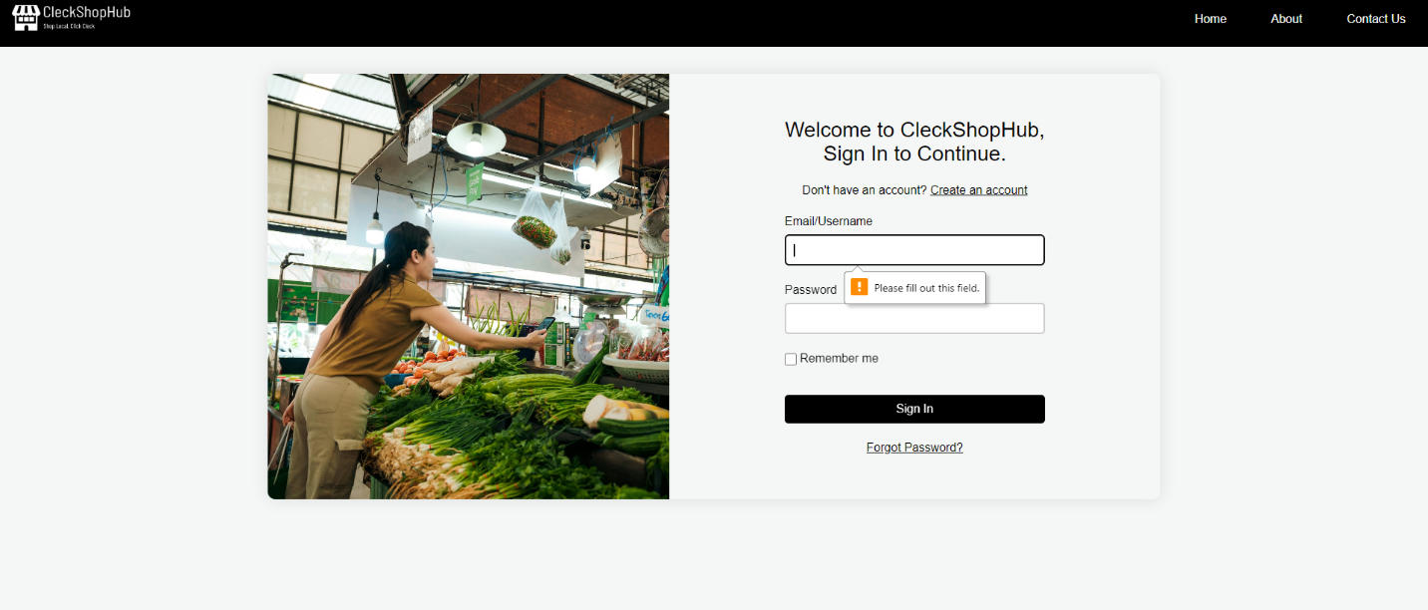

* If the trader provides a contact number that is less than or greater than 10 digits then following error message is shown

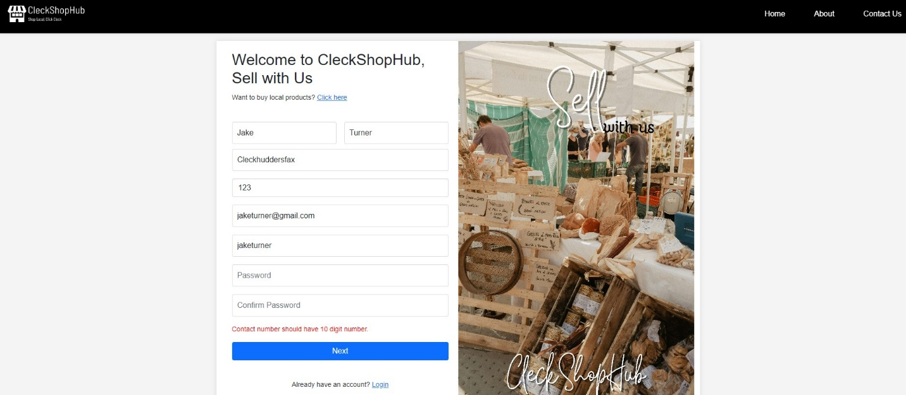

* If the trader provides a username that is already being used by an existing user then an red error message is shown

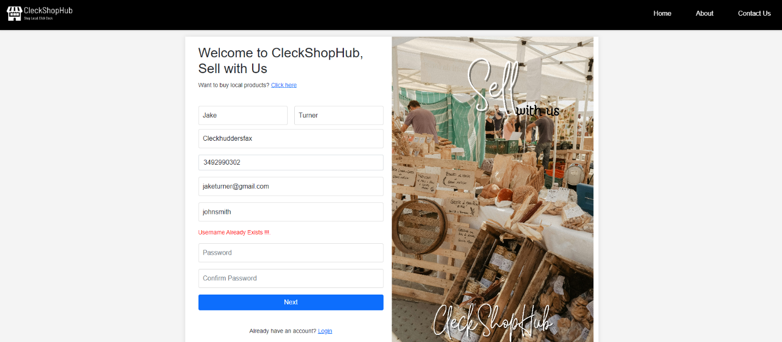

* If the trader inputs a date of birth that results in the age being lesser than 12 then a red error message is shown displaying that the trader is not eligible to register
* If the trader provides a contact number that is already being used by another existing trader or customer then the following error message is displayed

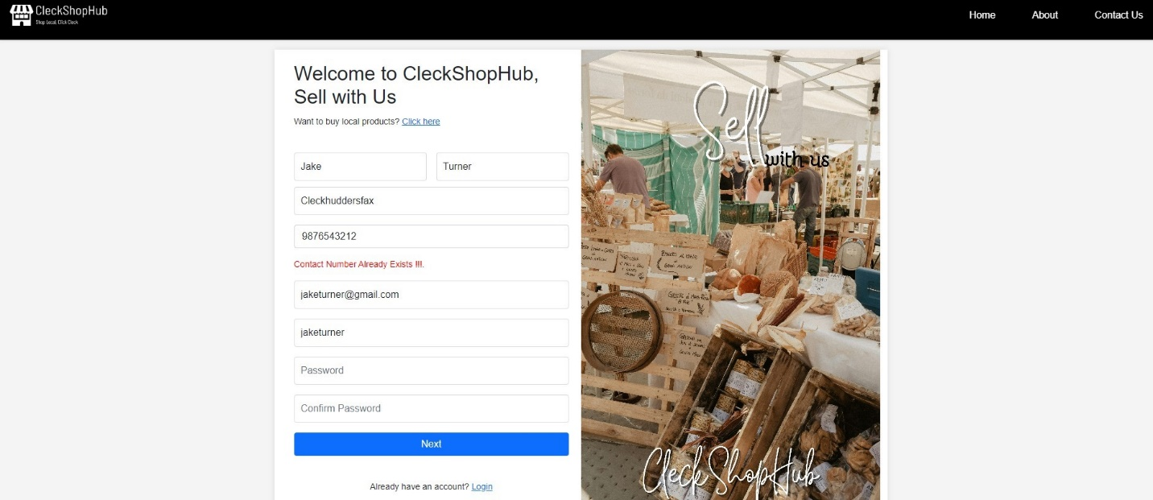

* If the trader’s password and confirm password input field values do not match then a red error message is displayed.

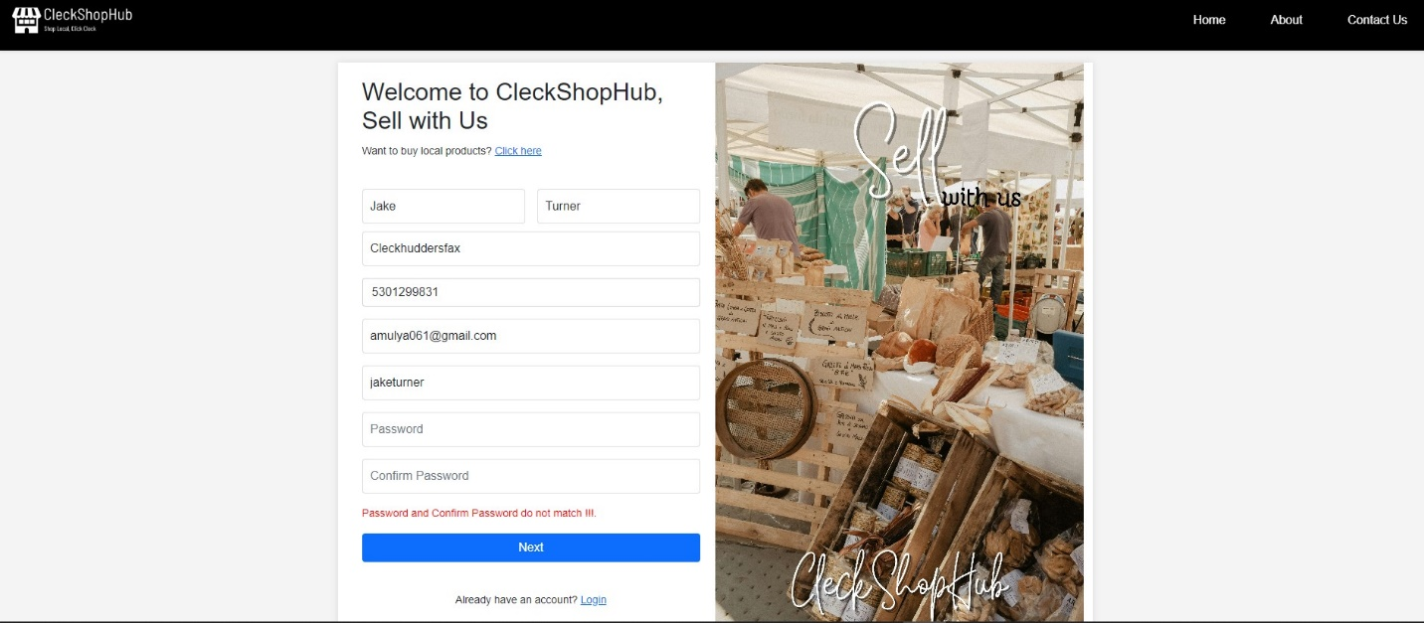

* If the trader inputs the password that is lesser than 8 or greater than 32 characters then the following error is shown

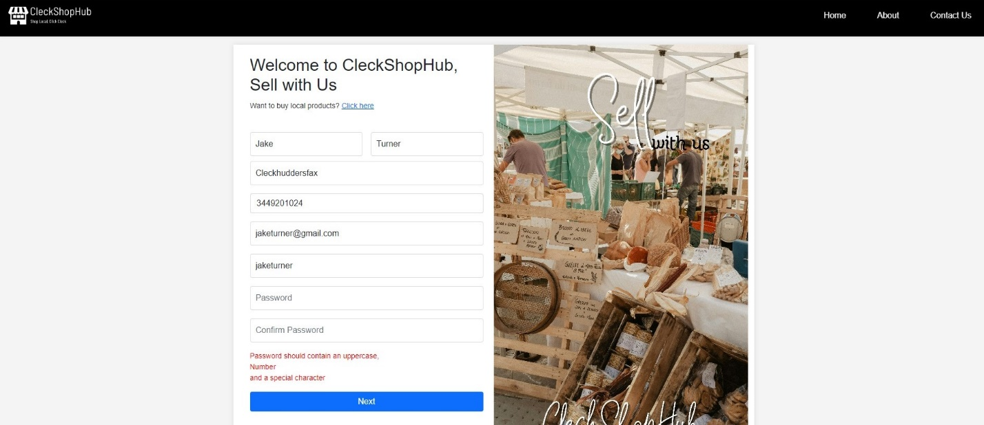

* If the trader provides a password with no uppercase letter or number or a special character then a red error message is displayed



* If the trader provides all the information that are valid then the trader is directed to shop details page where the trader can enter their shop details
* After successfully registering, the trader gets an OTP validation code sent to their email address.

[Login Testing]

* If the trader provides valid details in the login page then the trader is directed to Trader panel.

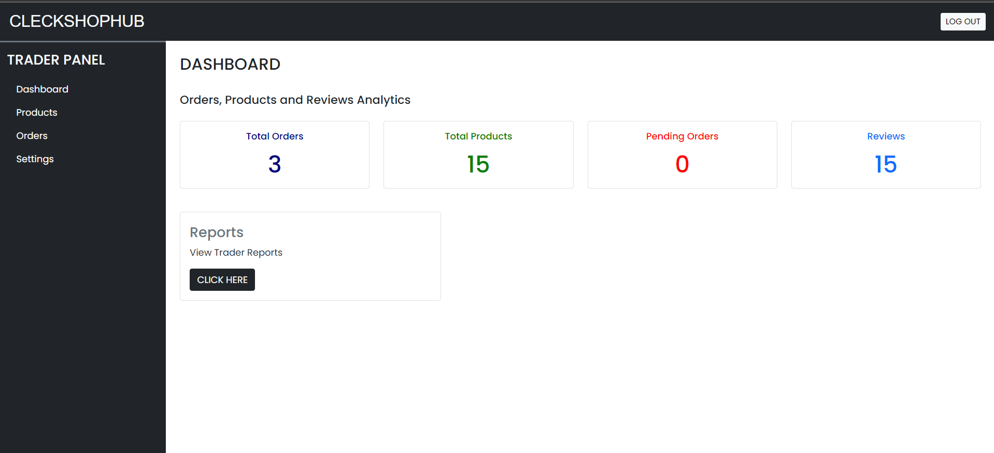

* If the trader provides invalid email or username or a password then a red error message is displayed informing the user that the entered email/username or password is not valid

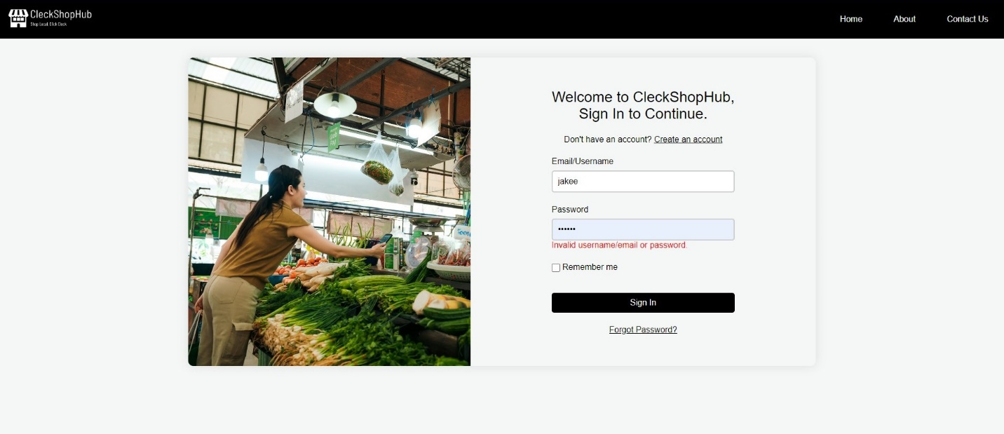

* If the trader ticks the Remember me checkbox then the trader is not required to enter their email or address details again



* If the trader clicks on the Forgot password link then the trader is instructed to provide their email address first, then the trader receives an OTP code sent to their email address and they can finally change their password.

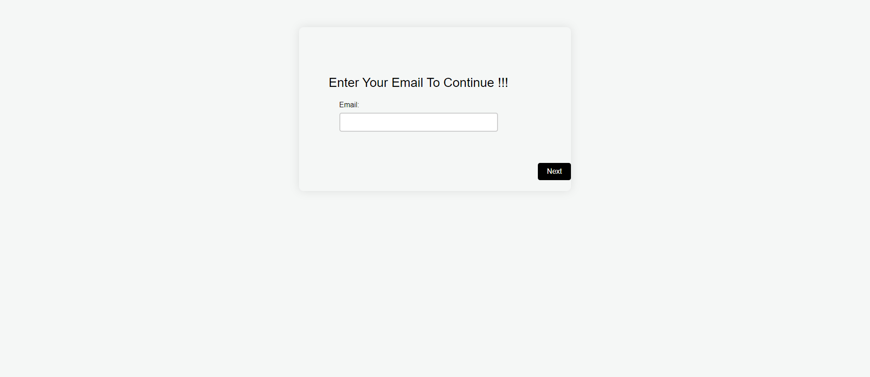

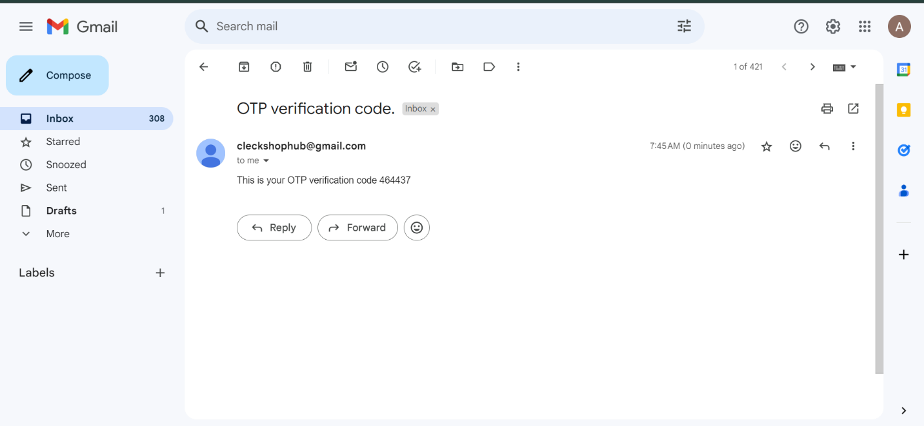

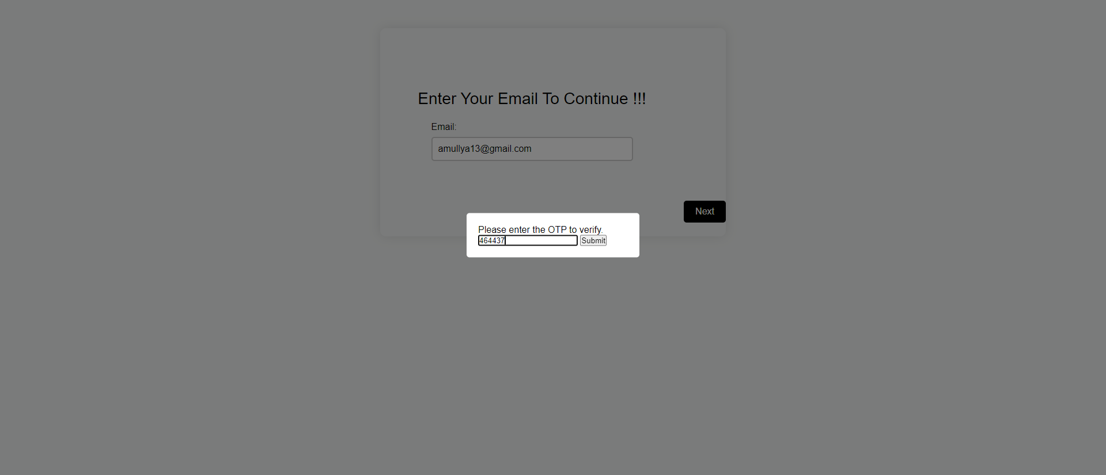

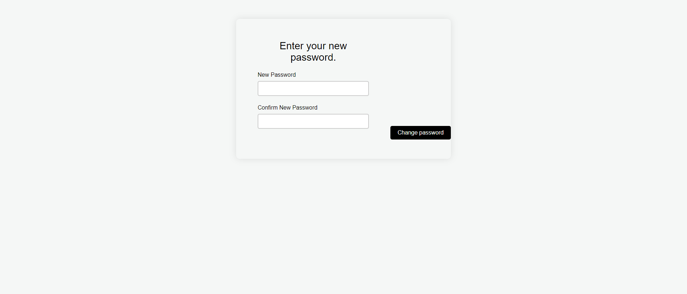

* If the trader clicks on Sign In button without providing any details then a message is displayed prompting the trader to fill out the empty fields.



[Trader Panel Testing]

* If the trader clicks on “Click Here” on Report section then the trader is redirected to Oracle Apex Trader Report
* If the trader clicks on “edit” button on profile settings then the trader can edit their personal details

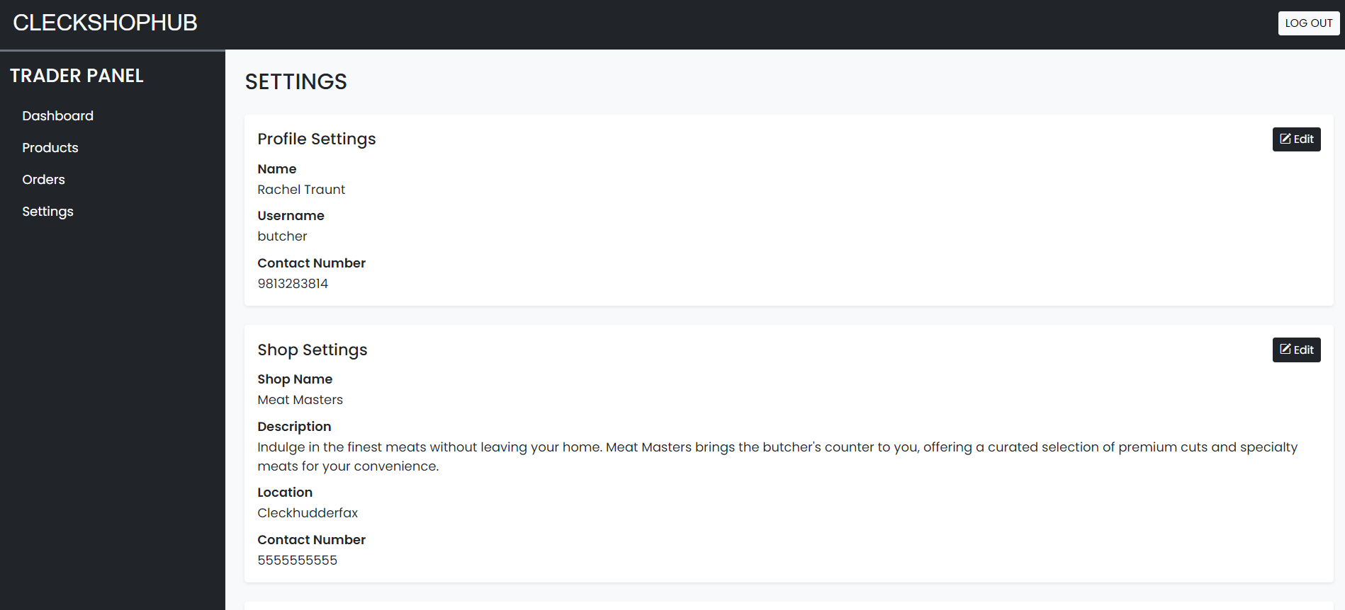

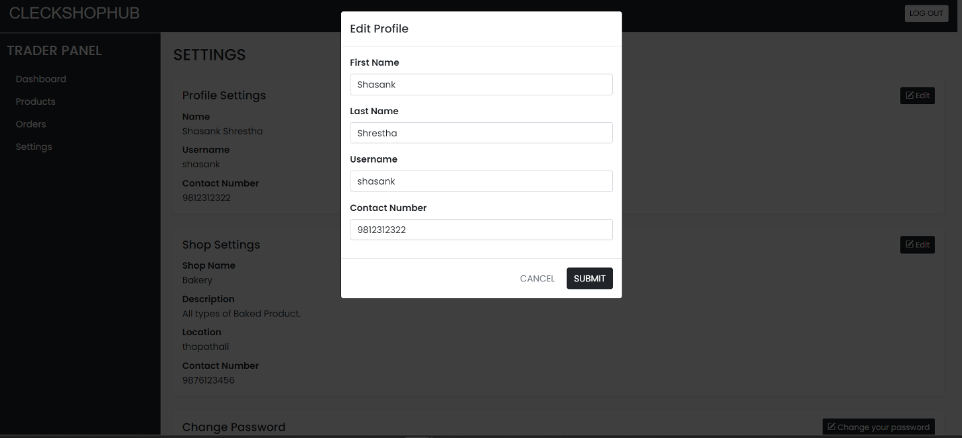

* If the trader clicks on “edit” button on shop settings then the trader can edit their shop details

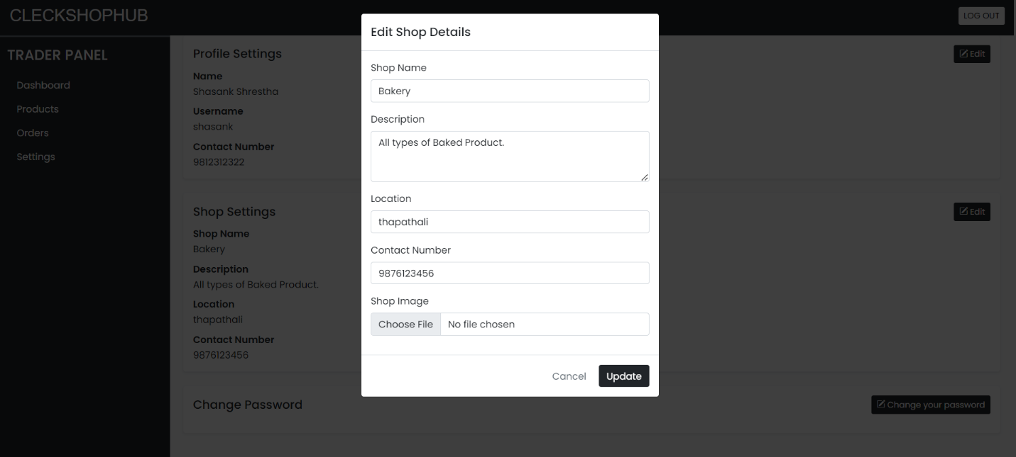

* If the trader clicks on change password button then trader can change password from the trader panel

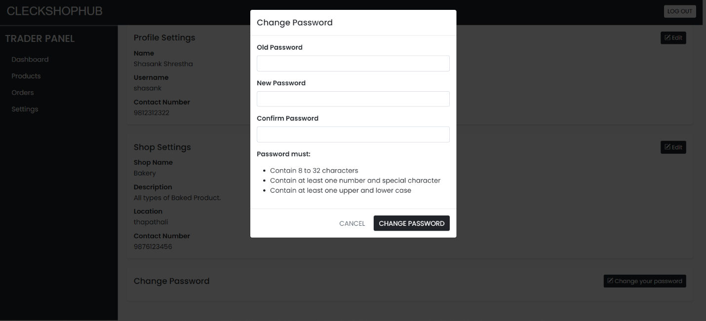

[Products Testing]

* If the trader clicks on Products tab on right side then trader can view all the product they have on their shop

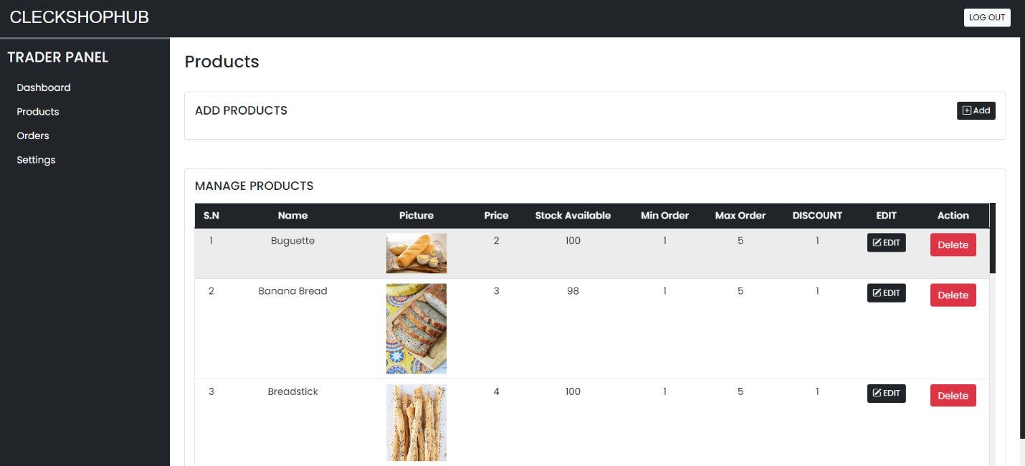

* If the trader clicks on “add” button on Products tab then the trader can insert their products in the shop after providing details about their products such as the product name, quantity and allergen information along with a picture of their product.

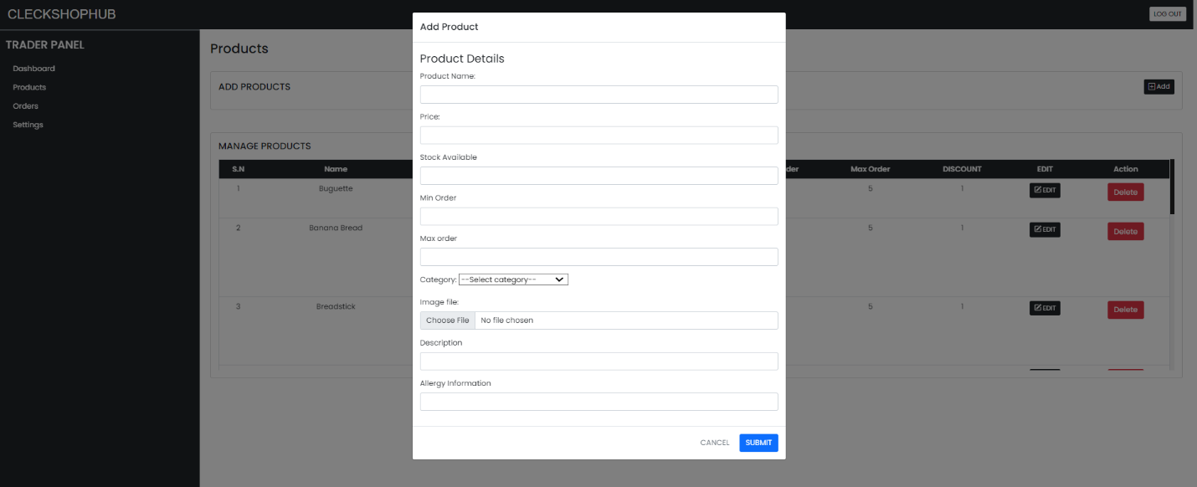

* If the trader clicks on “edit” button on products tab then the trader can edit the details about existing products in their shop

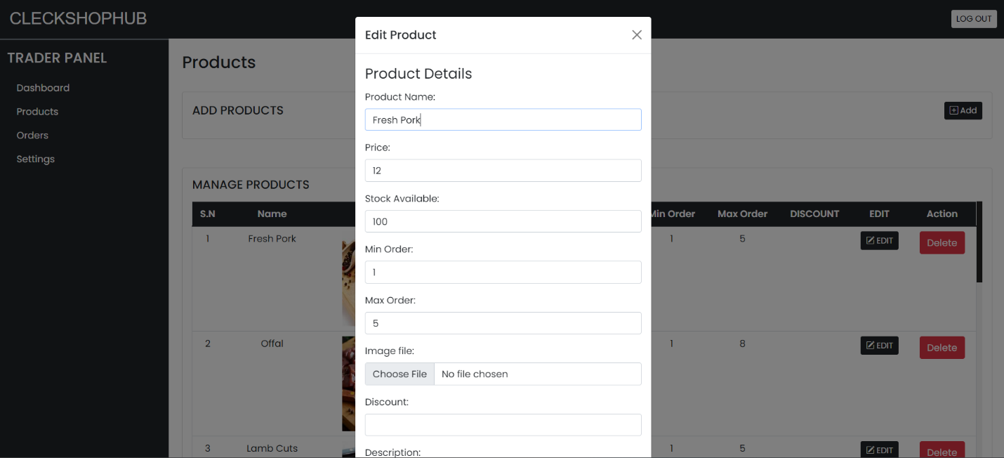

* If the trader clicks on the red “delete” button then the trader can delete products from their shop

[Orders Testing]

* If the trader clicks on “View Order” button on Orders tab then the trader can view all the order summary

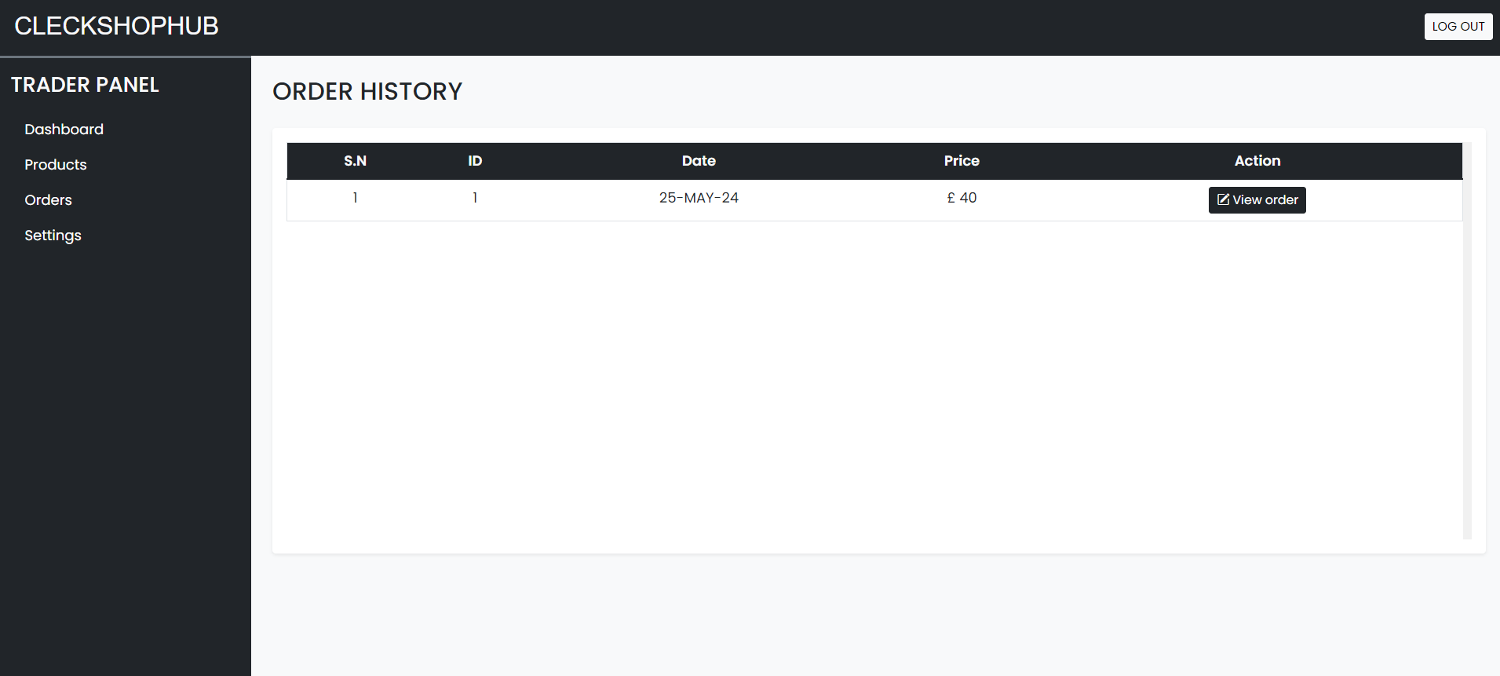

[Logout Testing]

* If the trader clicks on logout button on top right of the navigation bar then the trader gets logged out and redirected to the homepage.